Средние группы. «Весенняя песенка»
https://yandex.ru/video/preview/?filmId=5679329986038411883&parent-reqid=1587739457189988-1418077834195118793800133-production-app-host-vla-web-yp-63&path=wizard&text=%D0%B2%D0%B5%D1%81%D0%B5%D0%BD%D0%BD%D0%B8%D0%B5+%D0%BF%D0%B5%D1%81%D0%B5%D0%BD%D0%BA%D0%B8+%D0%B4%D0%BB%D1%8F+%D0%B4%D0%B5%D1%82%D0%B5%D0%B9+%D0%BF%D0%B5%D1%81%D0%BD%D1%8F+%D0%95%D0%B2%D1%82%D0%BE%D0%B4%D1%8C%D0%B5%D0%B2%D0%BE%D0%B9+%D0%92%D0%B5%D1%81%D0%BD%D0%B0+%D0%BF%D1%80%D0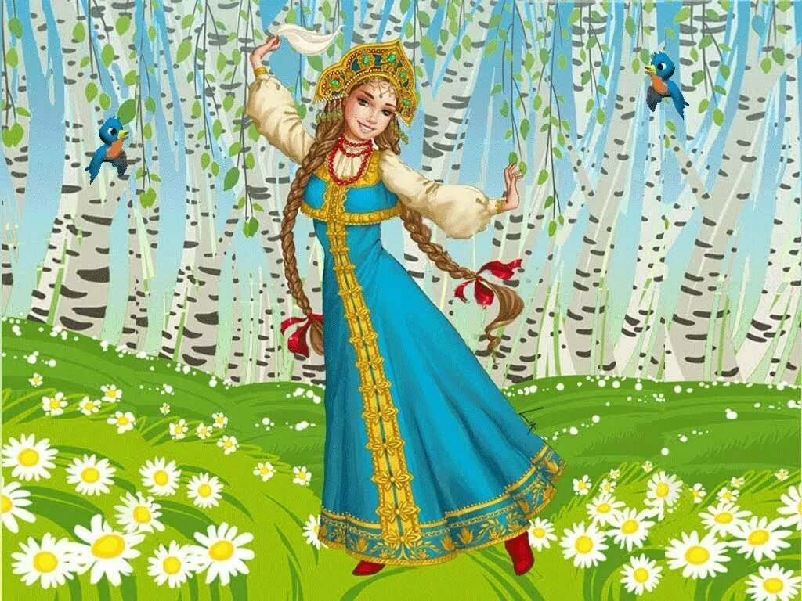%B8%D1%88%D0%BB%D0%B0+%D0%BE%D0%BF%D1%8F%D1%82%D1%8C

